
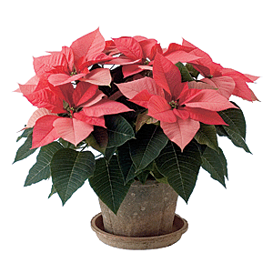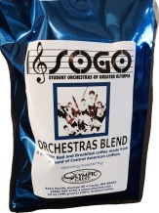
PLACE YOUR 2016 HOLIDAY ORDER TODAY!
STUDENT ORCHESTRAS OF GREATER OLYMPIA
1629 22ND Ave SE
Olympia WA 98501
studentorchestras.org or Facebook
studentorchestras@gmail.com
360.352.1438
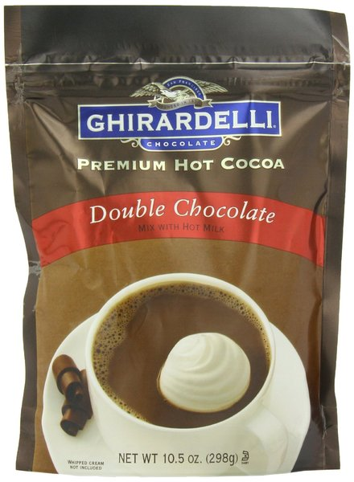
Orders are due by November 13
E-mail _____________________________
Contact Name ______________________________________ Company _____________________
Address_________________________________________________ City_____________________
Phone Home_________________ Work______________________ Cell_____________________
I ordered 20 or more poinsettias/wreaths and would like them delivered □ Yes □ No
If delivered, please provide address if different than above: _____________________________________________________________

Images available online at www.studentorchestras.org
Super Deal
3” 4 ½” 6” 8” 10 ½”
RED ________ ________ ________ ________ ________
PINK ________ ________ ________ ________ ________
WHITE ________ ________ ________ ________ ________
MARBLE ________ ________ ________ ________ ________
PICASSO/Pink Candy ________ ________ ________ NA NA
JINGLE BELLS ________ ________ ________ NA NA

Number of Plants ________ ________ ________ ________ ________
X price per plant $5 $10 (1-9) $16 (1-9) $40 $60
No discount $8 (10 or more) $14 (10 or more) No discount No discount
________ + ________ + ________ + ________ =___________
22” Noble Fir Wreath
Noble fir; red velvet water repellent bow and snowy pine cones for easy attachment. # _______ x $20 ea = ______________

SOGO Christmas Blend Coffee (12 oz) whole bean ground
$12 (1-9) and $10 (10 or more) # _______ x $__ ea = ___________

Ghirardelli Premium Hot Cocoa 10.5 oz. pouch (9 servings) # _______ x $10 ea = ___________
Total Due = ___________

METHOD OF PAYMENT: Check (payable to SOGO)
Visa MasterCard Exp. Date _______/______/_______

Credit card# _______________________________________________ CSV Code ________________
Phone # ___________________Signature _________________________________________________

Cut & keep for your records – Mail your orders to: SOGO - 1629 22nd Ave SE, Olympia WA 98501

Pick-up occurs Thursday, December 1, 4-6 p.m.

Allison home – 1629 22nd Ave SE, Olympia - Phone: 360.352.1438 | e-mails: Studentorchestras@gmail.com
A reminder: I ordered _________________________________________________________________

