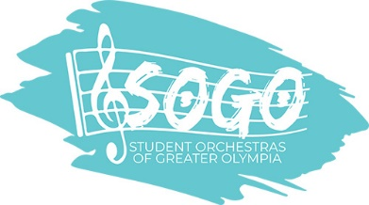
Advertising 2018-2019

Who is SOGO?
SOGO (Student Orchestras of Greater Olympia) is a program for youth to experience a broad cultural arts program through ensemble and orchestral performance. Musicians rehearse weekly and perform in and around the South Sound community during the season.

What does it cost to advertise with SOGO?
Full page (5 W X 8 H) $250
Half page (5 W X 4 H) $150
Business card (5 W X 2H) $100
Logo (New!) $75

Where is my ad used during the season?
- Your ad is placed in three (3) concert programs during the season held at the Washington Center (November 4, March 3 and May 19), with an average audience of 400+.
- The name of your business is also listed in SOGO’s fall newsletter to 2,150 recipients.
- Advertisers are also listed on our website at www.studentorchestras.org and we would gladly place a link to your business website too.

When is the ad due?
October 1.

When is the payment due?
You can pay when you send your ad to SOGO, or we will bill you in January.

How does SOGO like an ad prepared?
Ads in a Jpeg file can be sent to studentorchestras@gmail.com. If you are using your business card, we will make every effort to scan at the highest quality.

Questions? Contact: Krina Allison at 360.352.1438
__________________________________________________________________________________

Company____________________________ Contact Name _________________________
Address_______________________________ Website link ________________________
City________________________________________ State ________ Zip___________
Phone _____________________ e-mail__________________________________
Please check: □ JPEG or PDF will be sent to studentorchestras@gmail.com
□ A business card will be sent with this form

Please send this form with payment to:
SOGO ~ 1629 22nd Ave SE, Olympia WA 98501
□ Please check if you would like your payment deferred until January 14, 2019

